# Exercise 1

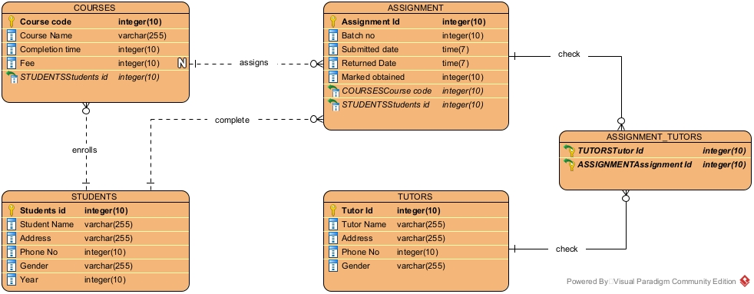

In this ERD, the entities are students, course, assignment, tutors. There is primary key in every entity so to make sure making relationship is possible. In Students entity, attributes are student id, student name, address, phone no. , gender, and year. In courses entity, attributes are course code, course name and fee. In assignment entity, assignment id, batch no. , submitted date, returned date and marks obtained. In tutors entity, attributes are tutor id, tutor name, address phone no. and gender.

Here a student can be enrolled in many courses at a time. A courses assigns many assignment to students. A student completes many assignment through the years. An assignment can be checked by many tutor and a tutor can check many assignments.

# Exercise 2

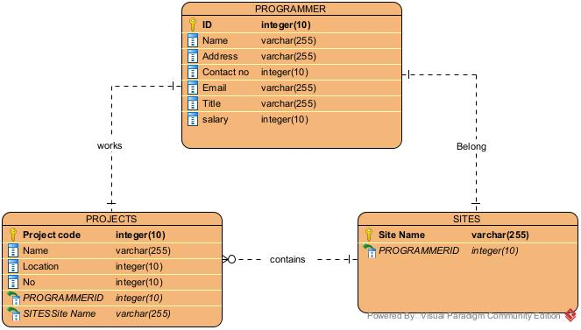

In this ERD, the entities are programmer, sites and projects. There is primary key in every entity so to make sure making relationship is possible. In programmer entity, attributes are id, name, address, contact no. , email, title and salary. In sites entity, attribute is site name. In projects entity, attributes are name, location and no. of programmers.

As shown in the ERD, a programmer belongs to only one site and works on only one project. A site hosts can many projects.

# Exercise 3

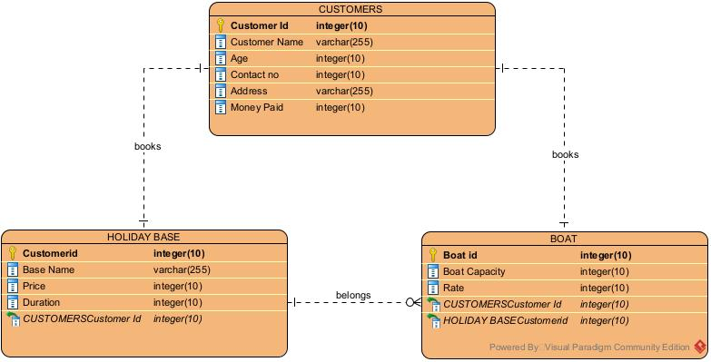

In this ERD, entities are customers, holiday base and boat. There is primary key in every entity so to make sure making relationship is possible. In customer entity, attributes are customer id, customer name, age, contact no. , address and money paid. In holiday base entity, attributes are customer id, base name, price and duration. In boat entity, attributes are boat id, boat capacity and rate of boat booked.

Here customer can book a holiday trip from a holiday base one at a time, and book a boat according the various specification. Any amount of boat present belongs to belongs to the holiday bases present.

# Exercise 4

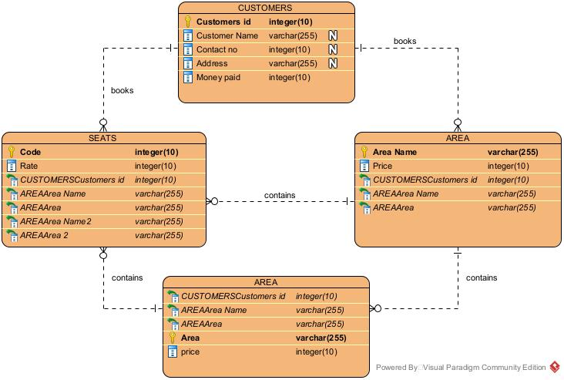

In this ERD, the entities are customers, area, area and seats. There is primary key in every entity so to make sure making relationship is possible. In customers entity, attributes are customers id, customer name, contact no. , address and money paid. In area entity the attributes are area name and price. In area sub entity, the attributes are area and price. In seats entity, the attributes are code and rate.

Here a customers can book many seats that can be in many area. An area may contain a sub area or many. Each area contains many seats.